**Python Timing your code:**

**Using list [] in 1st code**

**Using () in 2nd code**

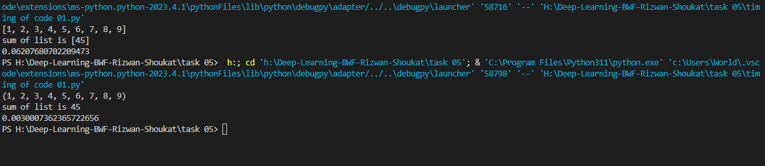

Creating a list using the () syntax is slightly faster than using the list [] function.

**Checking directly on shell.**

